3. Old milk jug

[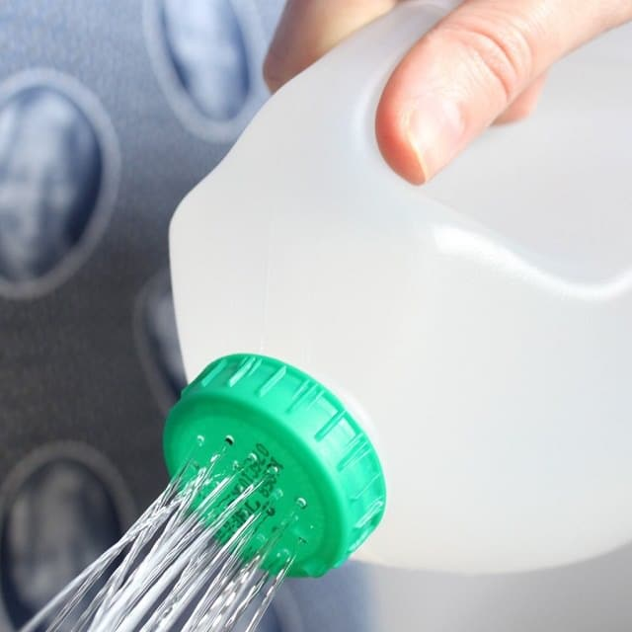](https://balconygardenweb-lhnfx0beomqvnhspx.netdna-ssl.com/wp-content/uploads/2016/06/No-watering-can-No-problem.jpg)

This super simple hack of an old milk jug is perfect for a new gardener that hasn’t gone out and bought a watering can yet. Just upcycle your old plastic milk jug by heating up a needle and poking holes in the lid so water can flow through it freely. Check out the [tutorial here](https://ajourneytoadream.blogspot.in/2012/03/helpful-yet-simple-diy-for-spring.html).

4. Use citrus peels to start seeds

[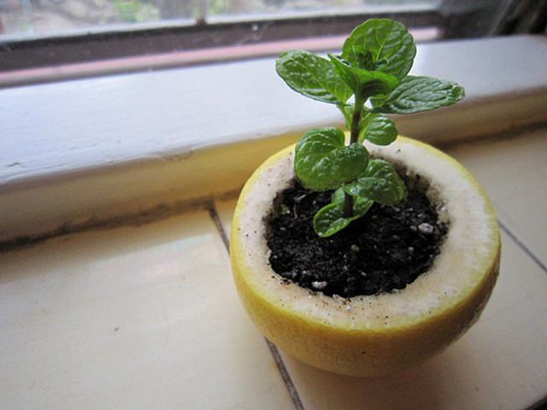](https://balconygardenweb-lhnfx0beomqvnhspx.netdna-ssl.com/wp-content/uploads/2016/06/Citrus-Peel-Starter-Pot2.jpg)

Just poke a hole in the bottom of the peel for drainage, fill it with potting soil, then sow seed and sprinkle some water. When the seedling is ready for transplant, plant it directly in a garden or in a container with the peel. The peel will decompose and nourish the young plant as it grows. Learn [more on it](http://www.myromanapartment.com/garden-hack-citrus-peel-starter-pot-seedlings/).

5. Used coffee filter in the botton of pot

[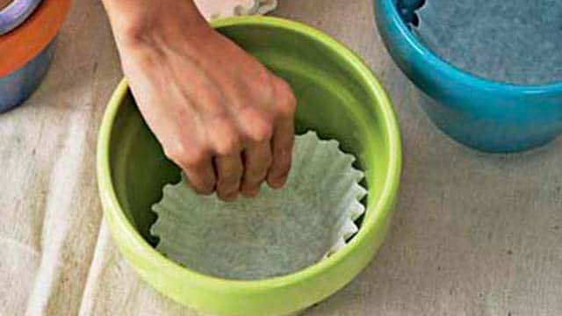](https://balconygardenweb-lhnfx0beomqvnhspx.netdna-ssl.com/wp-content/uploads/2016/06/coffee-filter-in-pot.jpg)

Next time you’re repotting a plant, keep the soil where it belongs with the help of a coffee filter. Simply lining the pot keeps the drainage holes in the bottom free from clogging up — and soil from sneaking out after watering. Learn [more on it](https://lifehacker.com/5926105/keep-houseplants-from-leaking-dirt-with-coffee-filters).

6. Use cooking water to fertilize plants

[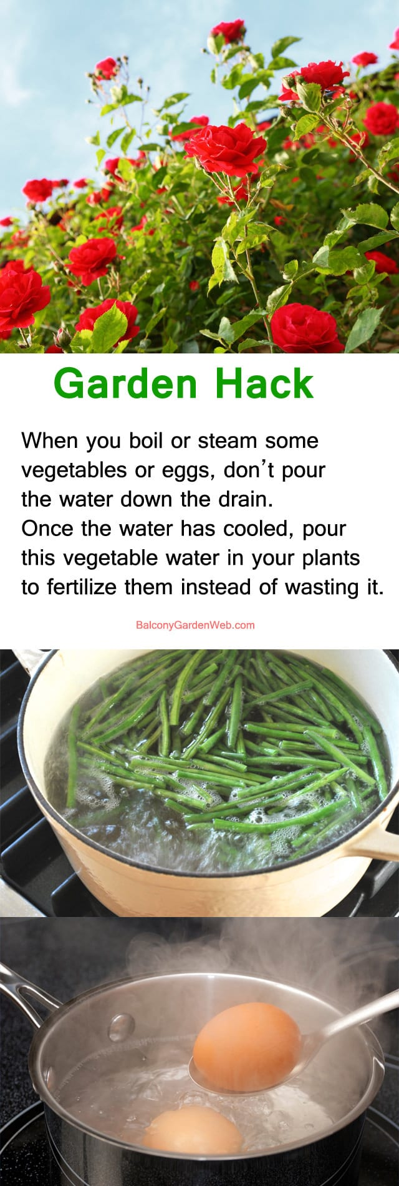](https://balconygardenweb-lhnfx0beomqvnhspx.netdna-ssl.com/wp-content/uploads/2016/06/garden-hack-use-cooking-water.jpg)

When you boil or steam some vegetables on the stove top, don’t pour the water down the drain. Once the water has cooled, pour this vegetable water in your plants to fertilize them instead of wasting it. You can also do the same with your boiled egg water.

7. Benefits of banana peels and orange peels

[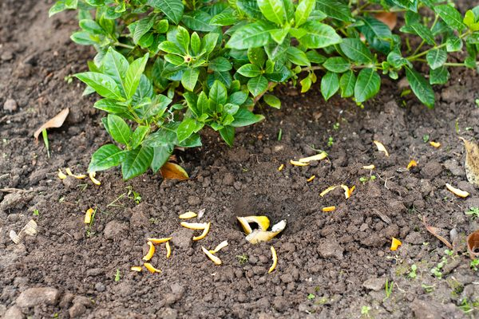](https://balconygardenweb-lhnfx0beomqvnhspx.netdna-ssl.com/wp-content/uploads/2016/06/Banana-Peels-Orange-Peels-in-the-Garden.jpg)

Before you toss another orange or banana peel into the trash, stop and think about the potential benefits you may be throwing away. Like other kitchen scraps, these peels can be added to the compost bin or used directly in the garden as a replacement for chemical fertilizers or insecticides. Check out [more on it](http://homeguides.sfgate.com/banana-peels-orange-peels-garden-31257.html).

8. Nutshells are a good addition

[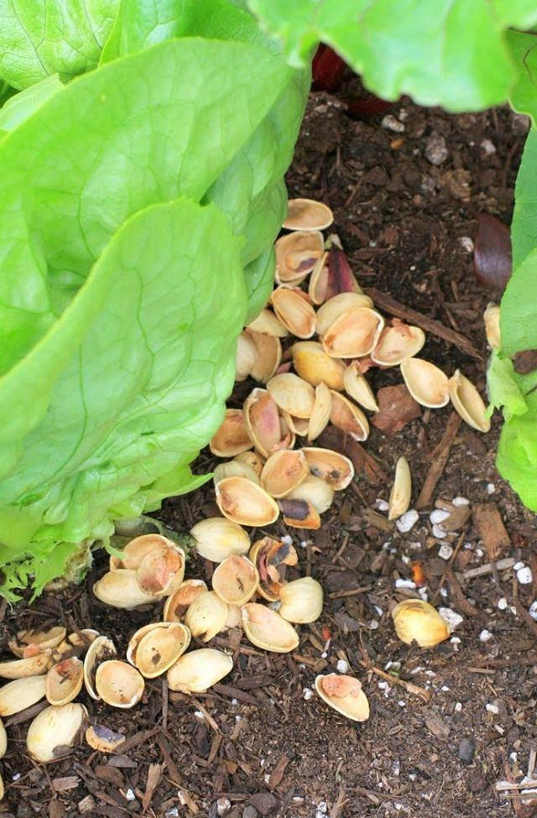](https://balconygardenweb-lhnfx0beomqvnhspx.netdna-ssl.com/wp-content/uploads/2016/06/nut-shells-in-garden.jpg)

The Nut shells are a good addition to your compost heap because they don’t break down as quickly as other items. Nut shells also work well as a mulch, the reason is same– they don’t break down easliy. In compost, they can help vary the thickness of it, this later helps in soil aeration. A warning: don’t use black walnut nut hulls beacuse they have a large concentrations of juglone which is toxic to many plants.

9. Paper Towel Rolls

[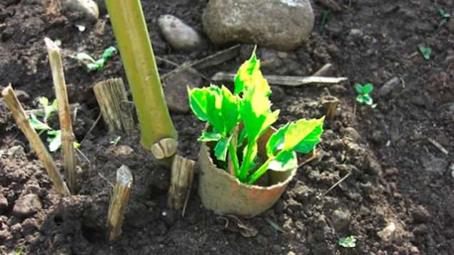](https://balconygardenweb-lhnfx0beomqvnhspx.netdna-ssl.com/wp-content/uploads/2016/06/17nifjo1gbc1djpg.jpg)

Instead of throwing out the paper towel roll, [use it in the garden](https://lifehacker.com/5912590/use-old-paper-towel-rolls-in-the-garden-to-protect-seedlings-from-pests). Cut it into peices and press it into the soil around your newly planted seedlings to give them a extra protection from slugs and other ground dwelling pests. You can also use paper towel rolls as seed starters (*you can also use toilet paper rolls), [check out](http://www.urbanorganicgardener.com/2010/03/using-toilet-paper-roll-to-start-seeds/).

10. Pepper Leftovers

[](https://balconygardenweb-lhnfx0beomqvnhspx.netdna-ssl.com/wp-content/uploads/2016/06/pepper-in-garden.jpg)

Use the leftovers from peppers, such as seeds and the tops to keep garden pests in away. Blend the waste, strain, mix with water in a spray bottle and use the spray to deter pests from your plants.

**Also Read:** [Organic Pest Control Recipes](https://balconygardenweb.com/organic-pest-control-approaches/)

11. Fruit and vegetable scraps

[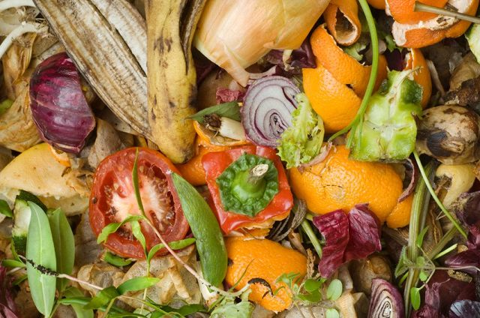](https://balconygardenweb-lhnfx0beomqvnhspx.netdna-ssl.com/wp-content/uploads/2016/06/fruit-and-veggies-crap.jpg)

Although you can simply compost fruit and vegetalbe scraps in compost pile, you can also put them through a food processor and use them around your tomatoes, peppers, and more to feed them. Peppers and tomatoes love this and you can expect a bumper harvest.

12. Food That Magically Regrows Itself from Kitchen Scraps

[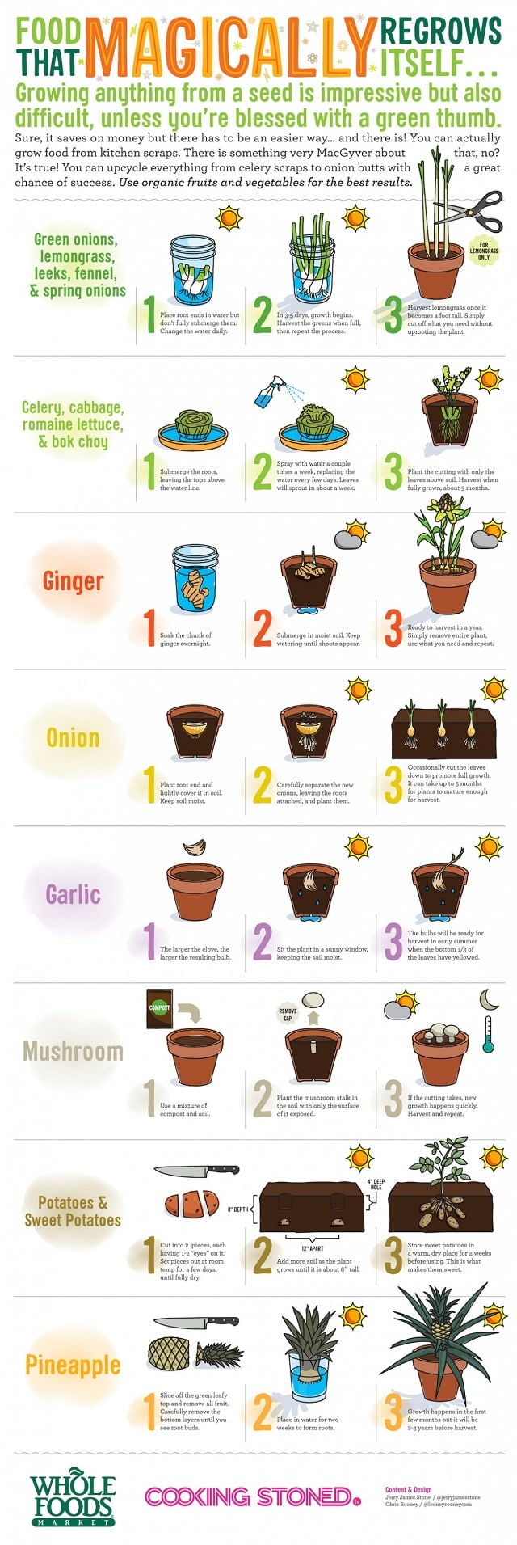](https://balconygardenweb-lhnfx0beomqvnhspx.netdna-ssl.com/wp-content/uploads/2016/06/regrow-food-from-kitchen-scraps-infographic-1.jpg)via [Jerryjamesstone](http://jerryjamesstone.com/blog/2014/02/food-that-magically-regrows-itself-from-kitchen-scraps/)

Let’s face it, eating well is expensive. Luckily, you can save a few bucks off your grocery bill by growing a few of those staples from your diet. Best part, it is much easier than you think. You don’t need seeds or anything fancy. You can simply use kitchen scraps from your next meal. Check out this infographic to learn how to grow food from kitchen scraps.